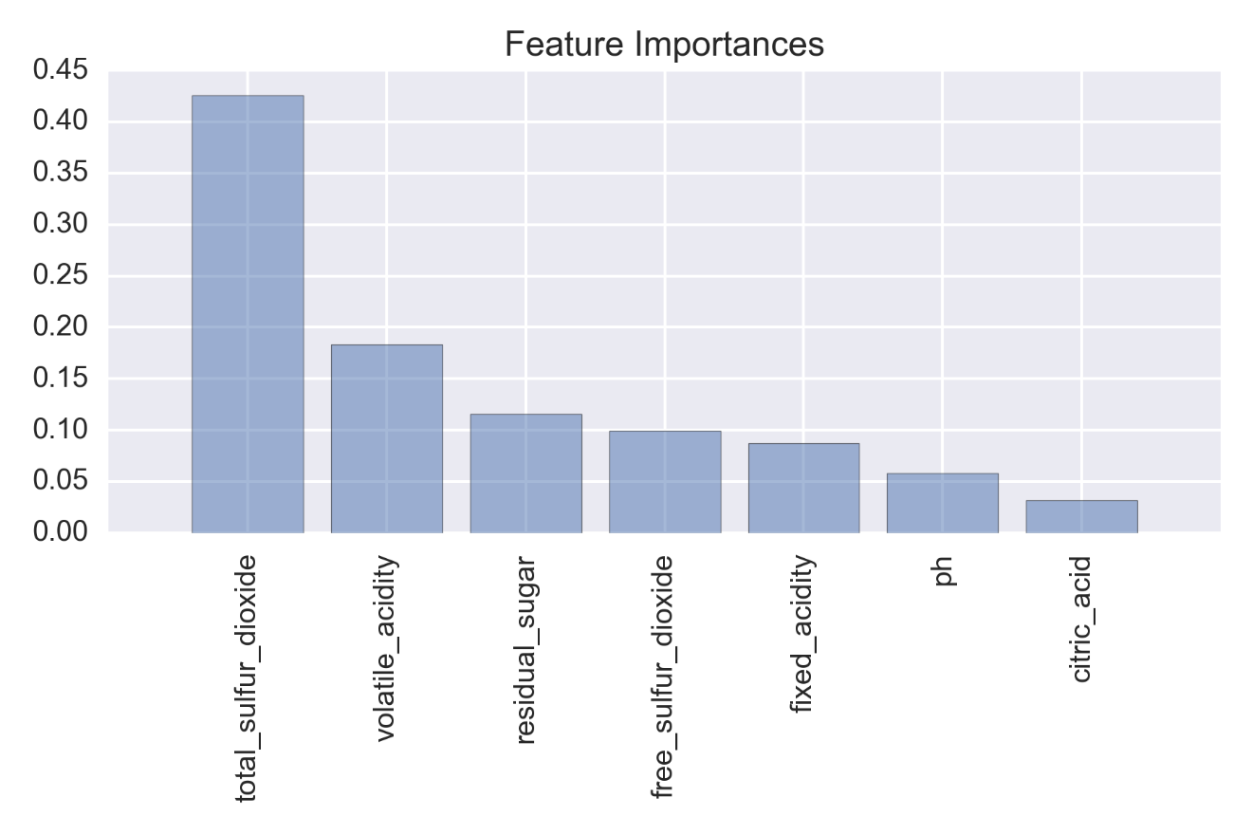

Rank of the features by importance:

1) total_sulfur_dioxide 0.425395

2) volatile_acidity 0.183220

3) residual_sugar 0.115321

4) free_sulfur_dioxide 0.099684

5) fixed_acidity 0.086874

6) ph 0.058083

7) citric_acid 0.031424